

**VNM SIMULATION., JSC**

**VNM DIRECT DRIVE CONFIGURATION MANUAL**

Contents

**VNM SIMULATION., JSC** 1

**1. UI Configuration** 2

**1.1. Basic Mode** 2

**1.1.1. Force Settings** 3

**1.1.2. Smoothness** 3

**1.1.3. Steering** 3

**1.1.4. Base Status** 4

**1.1.5. Save Profile** 5

**2. Game Tunning** 6

**2.1. Effects description** 6

**2.2. Game Tunning** 7

# **1. UI Configuration**

## **1.1. Basic Mode**

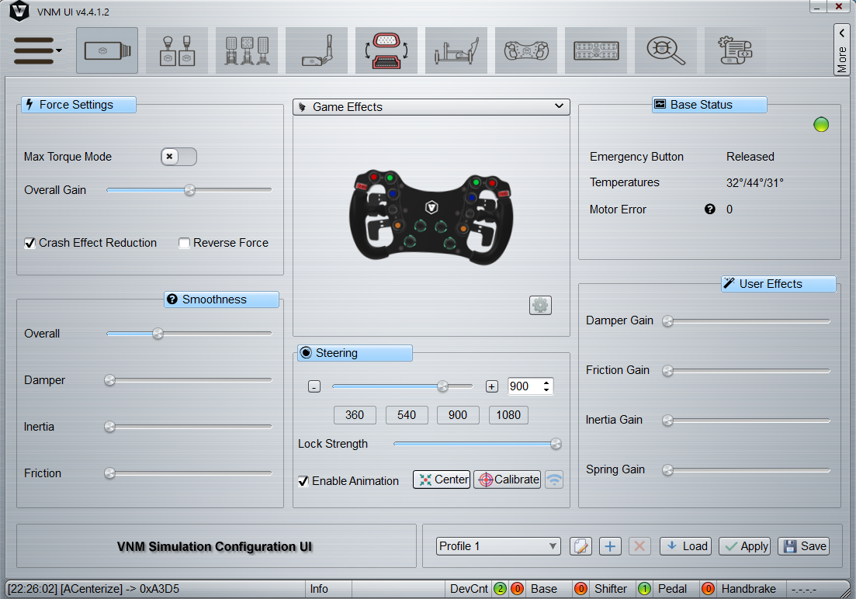

Basic Mode Direct Drive Configuration

Full Mode Direct Drive Configuration

### **1.1.1. Force Settings**

|  |  |  |
| --- | --- | --- |
| **Name** | **Description** | **Default Value** |
| Max Torque Mode | Twice the force when turn on | off |
| Overall Gain | the higher overall gain, the higher final force. | 50% |
| Crash Effect Reduction | Limit rotation speed of steering wheel | checked |
| Reverse Force | Reverse force data of game | unchecked |

### **1.1.2. Smoothness**

The smaller smoothness value, the smoother force feedback.

|  |  |  |
| --- | --- | --- |
| **Name** | **Description** | **Default Value** |
| Overall | Smooth total force | 150 |
| Damper | Only smooth damper force | 0 |
| Inertia | Only smooth inertia force | 0 |
| Friction | Only smooth friction force | 0 |

### **1.1.3. Steering**

|  |  |  |
| --- | --- | --- |
| **Name** | **Description** | **Default Value** |
| Steering Angle | Maximum angle from the left to the right of steering wheel. Click “-“, “+” to decrease or increase angle. There are some option to set quickly plus input for angle too. | 900 |
| Lock Strength | The maximum force to lock the wheel at maximum force | 10000 |
| Enable Animation | Animates steering wheel movement | NA |
| Center | Reset the wheel position to 0 | NA |
| Calibrate | Do calibration process. The calibration process automatically after update firmware. Only do calibration process when steering movement is not smooth without force feedback being applied | NA |

### **1.1.4. Base Status**

|  |  |  |
| --- | --- | --- |
| **Name** | **Description** | **Default Value** |
| Emergency Button | The Emergency Stop Button must be connected to the DD and the EMC Stop Button released for the DD to operate. The EMC Stop button attempts to stop the DD immediately when it is pressed | NA |
| Temperature | Temperature of mosfet, driver and brake resistor respectively. | /0/0/0 |
| Motor Error | Error code of motor | 0 |

Motor code Error translation

|  |  |  |  |
| --- | --- | --- | --- |
| Bit | Severity | Description | Solution |
| 0 | Critical | Internal Error | Reset direct drive |
| 1 | Critical | Over Voltage Protection | Reset direct drive |
| 2 | Critical | Over Current Protection | Reset direct drive |
| 3 | Critical | No response from Encoder | Reset direct drive, check encoder connection |
| 4 | Critical | Encoder value is abnormal | Reset direct drive, check encoder connection |
| 5 | Critical | Encoder internal error | Reset direct drive |
| 6 | Critical | Brake temperature is too high | Turn of DD 30 minutes |
| 7 | NA | Reversed |  |
| 8 | Major | EMC Stop Pressed | Release EMC Stop Button |
| 9 | Major | USB disconnected | Connect USB cable to PC |
| 10 | Major | Over Voltage Protection | Press and release EMC Stop Button |
| 11 | Major | Under Voltage Protection | Press and release EMC Stop Button |
| 12 | Major | Mosfet temperature is high | Turn off DD at least 5 minutes |
| 13 | Major | Driver temperature is high | Turn off DD at least 60 minutes |
| 14 | Major | Brake temperature is high | Turn off DD at least 5 minutes |

1.4.5. Game Effects

Click to “Game Effects”. You can increase gain to each effect of game data

Enable Telemetry FFB: Future use.

1.4.6. User Effects

User can add some effect to simulate nature of steering wheel movement.

|  |  |  |
| --- | --- | --- |
| **Name** | **Description** | **Default Value** |
| Spring | Make the steering wheel try to center all time. | 0 |
| Damper | Make the steering wheel less oscillation | 0 |
| Inertia | Simulate the steering wheel weight | 0 |
| Friction | Simulate the friction of steering wheel | 0 |

### **1.1.5. Save Profile**



1 – Select profile: 1st to 4th profile are saved to Direct drive. From 5th profile is saved to PC.

2 – Rename selected profile

3 – Add new Profile

4 - Delete a selected profile, only from 5th profile

5 – Load profile from DD in case you want rollback a configuration hasn’t been applied to the DD.

6 - Apply the configuration to the DD.

7 – Save Configuration permanently to DD or PC.

# **2. Game Tunning**

## **2.1. Effects description**

|  |  |  |
| --- | --- | --- |
| Effect Name | Description | Picture of effects |
| Constant force | A steady force in a single direction |  |
| Ramp force | A force that steadily increases or decreases in magnitude |
| Square force | Create a square wave form force |
| Triangle force | Create a triangle wave form force |
| Sine force | Create a sine wave form force |
| Sawtooth Up force | Create a sawtooth up/down form force |
| Sawtooth Up force |
| Spring force | The force increases in proportion to the distance of the steering wheel from center. |  |
| Damper force | The force increases in proportion to the speed with which the user moves the steering wheel |  |
| Inertia force | The force increases in proportion to the acceleration of steering wheel |  |
| Friction force | The force is applied when the steering is moved and depends on the defined friction coefficient. |  |

Depends on each game user can increase/decrease gain of each force

## **2.2. Game Tunning**

|  |  |  |
| --- | --- | --- |
| Game | Game effect | User Effect |
| AC/ACC/iRacing/ F1 2020 | Constant gain, damper gain | All |
| AMS2 | Constant gain | All |
| Dirt4/Rally 2.0 | Constant gain, friction gain | All |
| Project car 2 | Constant gain, sine gain | All |
| Raceroom | Sine gain | All |
| RF 2 | Sine gain, damper gain | All |
| WRC Generation | Ramp gain, square gain, sine gain, spring gain, damper gain | All |
| WRC 10 | Constant gain, sine gain, spring gain, damper gain | All |
| To be updated |  |  |